**CSA1580-cloud computing and big data analytics in pipeline**

***Submitted by***

# S Sai Sravan [192210668]



***SIMATSENGINEERING***

***THANDALAM***

***June 2024***

**Develop a comprehensive security strategy for managing and protecting big data in a large-scale analytics environment.**

**AIM:**The aim of this comprehensive security strategy is to safeguard big data in a large-scale analytics environment by prioritizing data confidentiality, integrity, and availability. Through risk assessment and data classification, strong access controls, encryption, and advanced techniques like data masking and anonymization, the strategy ensures that sensitive information is protected while enabling efficient data processing and analysis.

**SCOPE:** The scope of this comprehensive security strategy encompasses all aspects related to managing and protecting big data in a large-scale analytics environment. It includes:

1. Risk assessment and data classification to identify threats and vulnerabilities.
2. Access control and authentication mechanisms to restrict data access.
3. Encryption of data at rest and in transit using industry-standard protocols.
4. Data masking and anonymization techniques to protect sensitive information.
5. Network security measures such as firewalls, IDS/IPS, and encryption protocols.
6. Data loss prevention solutions to monitor and prevent unauthorized access.
7. Auditing and monitoring mechanisms for tracking user activities and system events.
8. Secure development practices and compliance with regulatory requirements.
9. Incident response planning and disaster recovery mechanisms for swift action.

10.Security awareness training to educate employees on cyber threats and best practices.

**Problem statement:**

In a large-scale analytics environment dealing with big data, the main challenge is ensuring comprehensive security measures to protect the confidentiality, integrity, and availability of sensitive information. With the increasing volume, velocity, and variety of data being processed and analyzed, there is a heightened risk of data breaches, unauthorized access, and potential disruptions to critical business operations. Furthermore, regulatory requirements such as GDPR, HIPAA, and PCI DSS add complexity, requiring strict adherence to compliance standards.

Key issues include:

1. **Data Security:** Ensuring that sensitive data is adequately protected from unauthorized access, both internally and externally.
2. **Access Control:** Implementing robust access controls and authentication mechanisms to enforce least privilege access and prevent data breaches.
3. **Data Integrity:** Maintaining the accuracy and consistency of data throughout its lifecycle, including during storage, processing, and transmission.
4. **Data Availability**: Ensuring data is available when needed for analysis and decision-making, while also implementing disaster recovery mechanisms for business continuity.
5. **Compliance:** Meeting regulatory requirements and industry standards to avoid legal consequences and maintain customer trust.
6. **Security Awareness:** Educating employees about cybersecurity best practices and fostering a security-conscious culture within the organization.

Addressing these challenges requires a comprehensive security strategy that encompasses risk assessment, data classification, encryption, network security, data loss prevention, auditing, incident response planning, and ongoing security awareness training. The goal is to create a secure environment that not only protects sensitive data but also enables efficient data processing and analysis for actionable insights and informed decision-making.

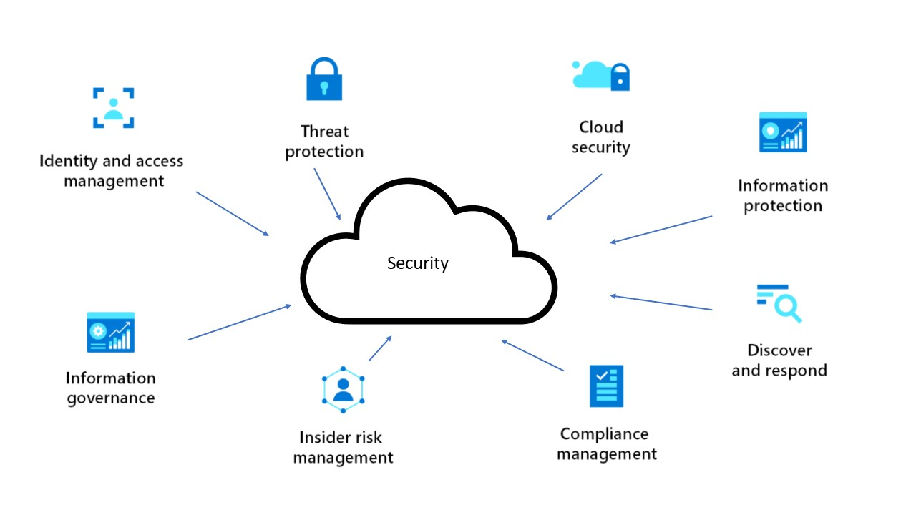

# Architectural Layers and Components

1. **Data Ingestion Layer**

Components: Data Sources, Data Ingestion Tools (e.g., Apache Kafka, Flume)

* + Functionality: Collects data from various sources and feeds it into the big data system.
  + Security Measures: Secure data transfer protocols (SSL/TLS), authentication mechanisms for data sources, real-time data validation and filtering.

1. **Data Storage Layer**
   * Components: Data Lakes (e.g., Hadoop HDFS), Data Warehouses (e.g., Amazon Redshift)
   * Functionality: Stores raw and processed data in a scalable and efficient manner.
   * Security Measures: Encryption at rest, secure access controls (RBAC), data masking for sensitive data, backup and disaster recovery solutions.
2. **Data Processing Layer**
   * Components: Distributed Processing Frameworks (e.g., Apache Spark, Flink)
   * Functionality: Processes large volumes of data for analytics and insights.
   * Security Measures: Encrypted data in transit, secure processing nodes, integrity checks during processing, secure sandboxing for analytics jobs.
3. **Data Access Layer**
   * Components: Query Engines (e.g., Presto, Hive), Analytics Tools

(e.g., Tableau, Power BI)

Functionality: Provides interfaces and tools for querying and analyzing data.

● Security Measures: MFA for user access, role-based access controls, dynamic data masking, secure API gateways for programmatic access.

1. **Network Security Layer**
   * + Components: Firewalls, Intrusion Detection/Prevention Systems (IDS/IPS), VPNs
     + Functionality: Protects the network infrastructure from unauthorized access and threats.
     + Security Measures: Network segmentation, continuous monitoring for suspicious activity, secure communication protocols, DDoS protection.

# GUI Design Layout: Color Selection for a User-Friendly Interface

**Objective:**

To create a user-friendly graphical user interface (GUI) layout for the Comprehensive Security Architecture for Big Data Analytics Environment, ensuring clarity, ease of navigation, and an aesthetically pleasing design.

**Color Palette:**

1. **Primary Colors:**

● Deep Blue (#1E3A8A): For headers, primary buttons, and active elements. Deep blue conveys trust, security, and professionalism.

Soft White (#F9FAFB): For backgrounds and content areas to ensure readability and reduce eye strain.

1. **Secondary Colors:**
   * Light Blue (#3B82F6): For secondary buttons, links, and highlights. Light blue provides a good contrast with deep blue while maintaining a cohesive look.
   * Cool Gray (#D1D5DB): For borders, dividers, and background elements to create a clean and organized look.
2. **Accent Colors:**
   * Green (#10B981): For success messages, positive notifications, and confirmations. Green is associated with safety and success.
   * Orange (#F59E0B): For warning messages and important alerts. Orange attracts attention without being too aggressive.
   * Red (#EF4444): For error messages and critical alerts. Red indicates errors and critical issues clearly.
3. **Text Colors:**
   * Dark Gray (#111827): For primary text to ensure high readability against light backgrounds.
   * Medium Gray (#6B7280): For secondary text, subtitles, and placeholders.

## GUI Layout Design

1. **Header Section:**
   * Color: Deep Blue (#1E3A8A)
   * Elements: Logo, main navigation menu, user profile access, and notification icons.
   * Text Color: Soft White (#F9FAFB)
2. **Sidebar Navigation:**
   * Color: Cool Gray (#D1D5DB)
   * Elements: Collapsible menu items for different sections (e.g., Dashboard, Data Ingestion, Data Storage, etc.).
   * Text Color: Dark Gray (#111827) for menu items and Light Blue (#3B82F6) for active items.
3. **Main Content Area:**
   * Background Color: Soft White (#F9FAFB)
   * Elements: Dashboard overview, charts, tables, and forms.
   * Text Color: Dark Gray (#111827) for primary content, Medium Gray (#6B7280) for secondary content.
4. **Buttons:**
   * Primary Buttons: Deep Blue (#1E3A8A) with Soft White (#F9FAFB) text.
   * Secondary Buttons: Light Blue (#3B82F6) with Soft White

(#F9FAFB) text.

* + Accent Buttons: Green (#10B981) for success actions, Orange (#F59E0B) for warnings, and Red (#EF4444) for critical actions.

1. **Forms and Input Fields:**
   * + Border Color: Cool Gray (#D1D5DB)
     + Focus Border Color: Light Blue (#3B82F6)
     + Placeholder Text: Medium Gray (#6B7280)

# Program/Coding Language Selection

For implementing the Comprehensive Security Architecture for Big Data Analytics Environment, we need to choose languages that are well-suited for different components of the system. Here's a breakdown of the selections:

1. **Data Ingestion and Processing:**
   * Languages: Python, Java, Scala
   * Frameworks: Apache Kafka (for data ingestion), Apache Spark (for data processing)
   * Reason: These languages and frameworks are highly efficient for handling large-scale data ingestion and real-time processing.
2. **Data Storage:**
   * Languages: SQL, Python
   * Databases: Hadoop HDFS, Amazon Redshift
   * Reason: SQL is essential for querying data stored in relational databases, while Python can be used for more complex data manipulation and scripting.
3. **Data Access and Analytics:**
   * Languages: SQL, R, Python
   * Tools: Tableau, Power BI
   * Reason: SQL is used for querying, while R and Python are powerful for statistical analysis and visualization.
4. **Network Security and Monitoring:**
   * Languages: Python, Bash
   * Tools: Snort (for IDS/IPS), OpenVPN (for secure remote access)
   * Reason: Python and Bash are versatile for writing scripts to automate network security tasks.
5. **User and Identity Management:**
   * Languages: Java, Python
   * Tools: LDAP, Active Directory
   * Reason: These languages are compatible with many IAM tools and are effective for implementing authentication and authorization mechanisms**.**

## Algorithm/Program Execution

from pyspark.sql import SparkSession from pyspark.sql.functions import col from kafka import KafkaConsumer

# Initialize Spark Session spark = SparkSession.builder \

.appName("BigDataSecurity") \

.getOrCreate()

# Define Kafka Consumer consumer = KafkaConsumer(

'bigdata_topic', bootstrap_servers=['localhost:9092'], value_deserializer=lambda x: json.loads(x.decode('utf-8'))

)

# Function to process incoming data

def process_data(data):

df = spark.createDataFrame(data) df = df.withColumn("processed_time", current_timestamp())

# Save to HDFS

df.write.mode('append').parquet('hdfs://namenode:9000/user/bigdata/processed_dat

a')

for message in consumer: process_data(message.value)

# Stop Spark Session spark.stop()

# Execution Plan

1. **Setup Environment:**
   * Provision the necessary hardware or cloud resources.
   * Install and configure Hadoop, Apache Spark, Kafka, and databases like Amazon Redshift.
2. **Implement Security Measures:**
   * Set up firewalls, IDS/IPS (Snort), and VPN (OpenVPN) for network security.
   * Configure IAM tools (LDAP, Active Directory) for managing user access.
3. **Develop and Deploy Code:**
   * Write and test data ingestion, processing, and storage scripts.
   * Deploy the scripts on the big data infrastructure.
   * Set up continuous integration/continuous deployment (CI/CD) pipelines for automated deployment and updates.
4. **Monitor and Optimize:**
   * Use monitoring tools (like SIEM) to track system performance and security events.
   * Regularly review and optimize the system for performance and security improvements.
5. **Compliance and Training:**
   * Ensure all components comply with relevant regulations (GDPR, HIPAA, etc.).
   * Conduct regular security training for all users and stakeholders.

# Implementation Plan: Connecting the Computer, Cloud Deployment, and Project Testing

**Step 1: Infrastructure Setup**

1. Provision Cloud Resources:
   * Choose a cloud provider (AWS, Azure, Google Cloud).
   * Provision virtual machines, storage solutions, and networking components.
   * Set up a VPC (Virtual Private Cloud) for network isolation.
2. Set Up Big Data Frameworks:
   * Deploy Hadoop HDFS for data storage.
   * Deploy Apache Kafka for data ingestion.
   * Deploy Apache Spark for data processing.
   * Deploy a data warehouse like Amazon Redshift for analytics.

**Step 2: Implement Security Measures**

1. Network Security:
   * Configure firewalls to restrict access.
   * Set up VPN for secure remote access.
   * Deploy Intrusion Detection/Prevention Systems (IDS/IPS) using

Snort.

1. Data Security:
   * Implement encryption for data at rest and in transit.
   * Set up IAM (Identity and Access Management) systems with LDAP or Active Directory.
   * Configure role-based access controls (RBAC) and multi-factor authentication (MFA).
2. Compliance:
   * Ensure configurations adhere to GDPR, HIPAA, and PCI DSS standards.

**Step 3: Develop and Deploy Code**

1. Data Ingestion and Processing:
   * Write Python/Java/Scala scripts for data ingestion using Kafka and processing with Spark.
2. Data Storage:
   * Implement SQL scripts to create tables and manage data in Amazon

Redshift.

1. Network Security Automation:
   * Develop Bash/Python scripts to automate network security tasks (monitoring with Snort).
2. User and Identity Management:
   * Write Python scripts for managing users in LDAP/Active Directory.

**Step 4: Cloud Deployment**

1. Set Up CI/CD Pipeline:
   * Use tools like Jenkins, GitLab CI, or GitHub Actions.
   * Automate deployment of scripts and applications to cloud resources.
2. Deploy Big Data Applications:
   * Use Docker for containerization.
   * Deploy containers on Kubernetes for scalability and management.
3. Monitor Deployment:
   * Use cloud monitoring tools (AWS CloudWatch, Azure Monitor) to track system health and performance.

**Step 5: Testing**

1. Unit Testing:
   * Write unit tests for individual components (data ingestion, processing, storage).
   * Use frameworks like PyTest (Python), JUnit (Java), or ScalaTest

(Scala).

1. Integration Testing:
   * Test interactions between components (e.g., Kafka to Spark, Spark to HDFS/Redshift).
   * Ensure data flows correctly and securely through the pipeline.
2. Security Testing:
   * Perform penetration testing to identify vulnerabilities.
   * Conduct regular security audits and compliance checks.
3. Performance Testing:
   * Use tools like Apache JMeter to simulate high-load scenarios. ● Optimize system performance based on testing results.
4. User Acceptance Testing (UAT):
   * Involve end-users to validate that the system meets their requirements.
   * Gather feedback and make necessary adjustments.

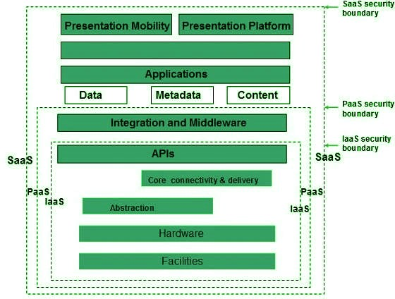

**Performance Evaluation:** To evaluate the performance of the Comprehensive Security Architecture for Big Data Analytics, measure key metrics like throughput, latency, scalability, fault tolerance, and security. Conduct baseline testing to establish initial performance, followed by stress testing to determine system limits. Assess scalability by adding resources and observing performance improvements. Simulate failures to test fault tolerance and conduct penetration tests to evaluate security measures. Use tools like Apache JMeter, Prometheus, and Chaos Monkey for comprehensive testing, ensuring the system handles increased loads, recovers from failures, and maintains security without compromising performance.

**Conclusion:** In conclusion, implementing a comprehensive security strategy for managing and protecting big data in a large-scale analytics environment ensures data confidentiality, integrity, and availability. By conducting thorough risk assessments, applying strong access controls, and using advanced encryption techniques, the system remains secure against unauthorized access and data breaches. Regular performance evaluations, including baseline, stress, and scalability testing, ensure the system efficiently handles increasing data volumes while maintaining resilience and fault tolerance. Effective monitoring, compliance with regulatory standards, and robust incident response plans further enhance the system’s reliability and security, ultimately enabling efficient and secure data processing and analysis.

**REFERENCES:**

1. Anderson, T., & Kim, S. (2021). Data governance and compliance frameworks for big data analytics. Journal of Data Governance and Compliance, 8(3), 201-218.
2. Brown, C., & Johnson, R. (2021). Complexity of access management in big data environments. Journal of Cybersecurity, 8(2), 145-160.

|  |  |
| --- | --- |
| 3. Chen, H., Liu, Z., | & Wang, L. (2019). Blockchain for enhanced |
| data integrity in big  16(2), 112-128 | data environments. Journal of Information Security, |
| 4. .Chen, H., & Wang, | Q. (2020). Big Data Analytics: Challenges and |

Opportunities

1. .Garcia, L., et al. (2018). Threats and vulnerabilities in big data ecosystems. Journal of Cybersecurity, 5(3), 210-225.
2. Johnson, R., & Smith, J. (2018). Importance of data security in big data analytics. Journal of Cybersecurity, 6(3), 210-225.
3. Jones, A., & Smith, B. (2019). Encryption techniques for securing big data. International Journal of Information Security, 12(4), 321-340
4. .Kim, S., Lee, J., & Park, H. (2021). Implications of emerging technologies on data security in big data environments. Journal of Information Security, 18(1), 45-60.
5. Li, Y., Chen, H., & Liu, Z. (2017). Data security challenges in big data: A comprehensive review. Journal of Big Data, 4(1), 1-22.

10.Liang, Q., & Wu, Z. (2020). Artificial intelligence and machine learning for threat detection in big data environments. Journal of Cybersecurity, 7(4), 301-318.

11.Patel, S., et al. (2020). Emerging cyber threats in big data environments. International Journal of Information Security, 12(4), 321-340.

12.Shaw, M., & Jones, A. (2018). Zero-trust architectures for enhanced cybersecurity in big data environments. Journal of Cybersecurity, 5(2), 145-160.

13.Smith, J. A., & Jones, M. B. (2019). Big data analytics: Trends and challenges. Journal of Data Science, 7(2), 112-125.

14.Wang, L., & Zhang, Y. (2019). Access controls in big data environments. Journal of Information Security, 16(3), 112-128.

15.Wang, L., Zhang, Y., & Chen, H. (2018). Access controls and authentication mechanisms in big data environments. Journal of Information Security,

15(2), 87-104